STOCK MAINTENANCE SYSTEM

USW CASE DIAGRAM

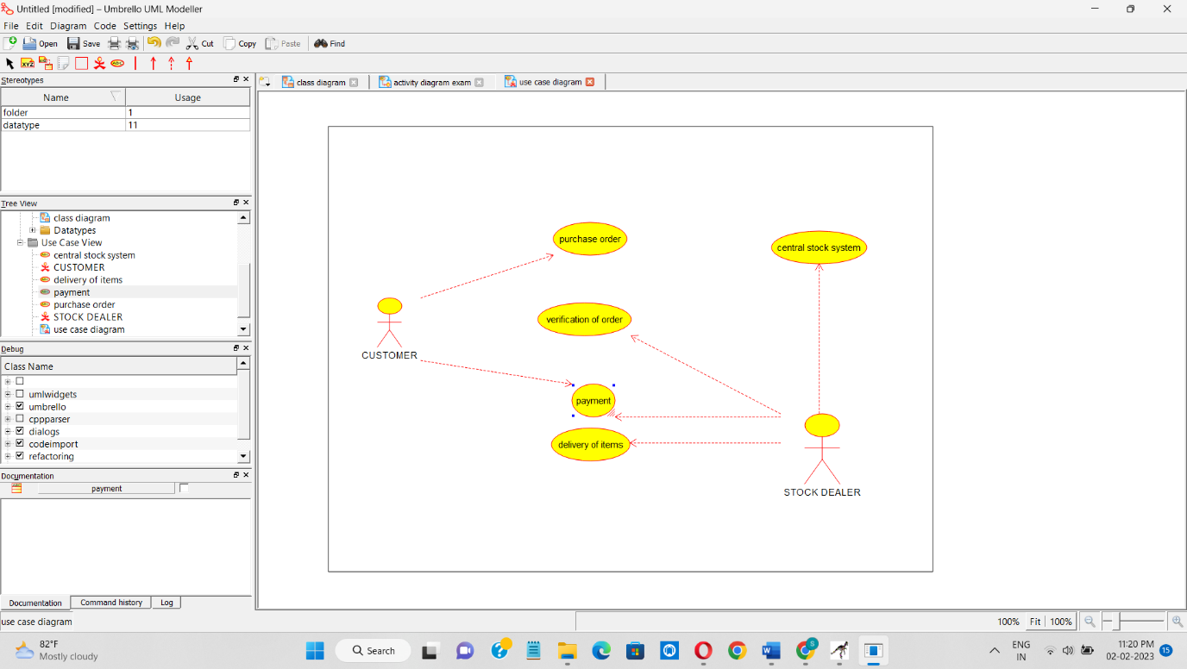

CLASS DIAGRAM

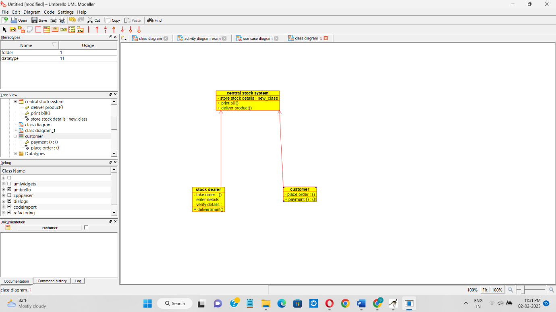

ACTIVITY DIAGRAM

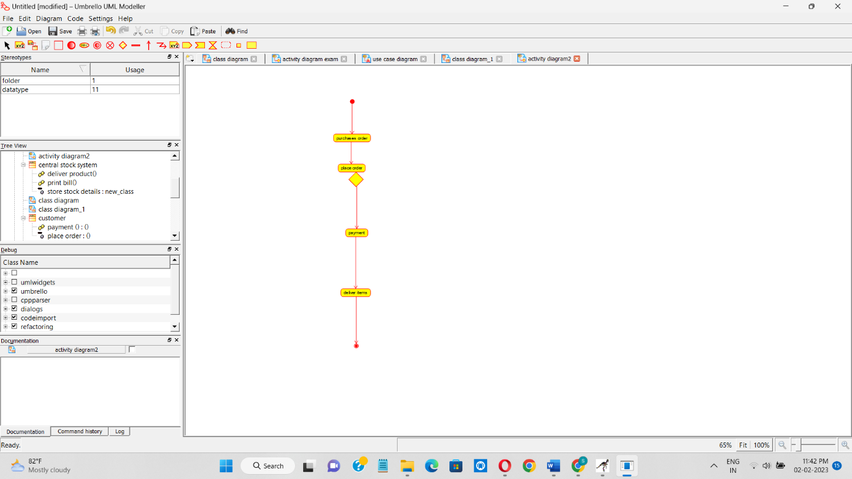

COLLABORATION DIAGRAM

